Batch: A-2 Roll No.: 16010122069

Experiment / assignment / tutorial No. 5

TITLE : ATAM - Architecture Trade-off Analysis Method for B.Tech Project.

AIM : To apply Human-centric analysis process ATAM for identifying risks early on in software design for the B E Project.

______________________________________________________________________

Expected OUTCOME of Experiment:

_____________________________________________________________________
Books/ Journals/ Websites referred:

1 “Software Architecture, Richard N Taylor etl, Wiley

2
______________________________________________________________________

Theory:

ATAM stands for architectural trade-off analysis method. This method Focuses specifically on four quality attributes (NFPs)
- Modifiability
- Security
- Performance
- Reliability

ATAM reveals how well an architecture satisfies quality goals and how
those goals trade-off.

ATAM Process:
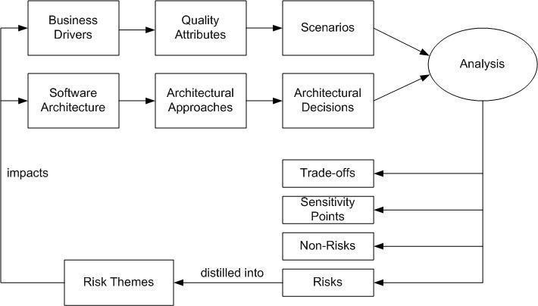

The following scenarios can be used:

- Use-case scenarios
  - Describe how the system is envisioned by the stakeholders to be used
- Growth scenarios
  - Describe planned and envisioned modifications to the architecture

- Exploratory scenarios
  - Try to establish the limits of architecture’s adaptability with respect to system’s functionality, operational profiles ,underlying execution platforms

- Scenarios are prioritized based on importance to
Stakeholders

ATAM in a nutshell:

Goals | Completeness
 | Consistency
 | Compatibility
 | Correctness`
Scope | Subsystem- and system-level
 | Data exchange
Concern | Non-functional
Models | Informal
 | Semi-formal
Type | Scenario-driven
Automation Level | Manual
Stakeholders | Architects
 | Developers
 | Managers
 | Customers

ATAM Analysis of B.Tech Project:

Title:

Business Drivers:

Software Architecture:

Quality Attributes:

Architectural Approaches :

Scenarios:

Analysis:

Trade-Off:

Sensitivity Points:

Risks:

Non-Risks :

Post Lab Descriptive Questions

1 . What are the other methods of NFP analysis

